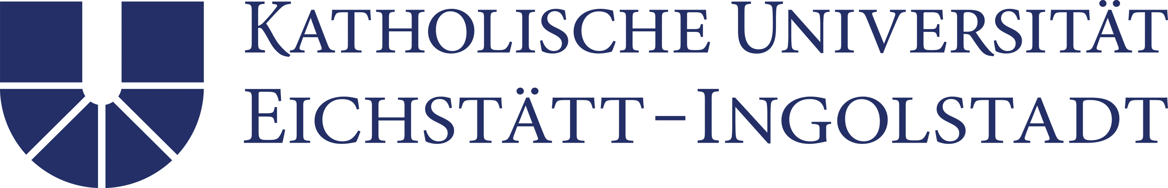

Sample form
Doctoral Supervision Agreement

Supervisor: LAST NAME, FIRST NAME……………………………………
Faculty, chair/professorship: ………………………………………………………………

Doctoral candidate: LAST NAME, FIRST NAME……………………………………

Working title of doctoral project:
…………………..………………………………………………………………………………
…………………..………………………………………………………………………………

This Supervision Agreement must be completed by the doctoral supervisor together with the doctoral candidate. If necessary, they will be supported by the Graduate Academy.
Please also note that this Doctoral Supervision Agreement will only come into effect after the doctoral candidate has been accepted by the doctoral committee of the relevant faculty. Any and all changes to this agreement require the signatories’ consent.

The present Supervision Agreement shall be governed by the general doctoral regulations of the Catholic University of Eichstätt-Ingolstadt and the respectively relevant faculty doctoral regulations of the relevant faculty as amended from time to time.
The present Supervision Agreement is drafted in accordance with the relevant recommendations of the German Research Foundation and the EU Principles for Innovative Doctoral Training.

- Object and purpose
This Supervision Agreement is an expression of mutual intention of both the supervisor and the doctoral candidate to engage in a trusting and productive cooperation with regard to the planned doctoral project. Within the meaning of a bilateral declaration of intent, it shall serve as a guideline; however, no legally effective claims can be derived from this.

- Persons involved
Doctoral candidate: | Last name, first name  Contact details
Supervisor: | Last name, first name, academic title  Contact details
Additional persons involved in the supervision process  (such as additional co-supervisors):  (if applicable at this stage) | Last name, first name, academic title  Contact details
Type of doctoral degree | Monographic - cumulative, if applicable language of doctoral project, Cotutelle etc.

- Short description of planned doctoral project

- Timeline and work schedule

- Tasks and obligations of doctoral candidate

- Tasks and obligations of doctoral supervisor

- Obligation to adhere to the principles of good scientific practice
By signing the present document, both parties commit themselves to adhere to the principles of good scientific practice in accordance with common national and international standards. At the same time, the signatories hereby confirm that they have acknowledged such recommendations and further undertake to observe the provisions of the KU “regulations on safeguarding standards of good scientific practice and dealing with allegations of scientific misconduct” as amended from time to time.

- Other arrangements and agreements

- Entry into force, duration of and changes to the Supervision Agreement
The supervisory relationship agreed herein shall enter into force upon acceptance of the doctoral candidate by the doctoral committee and shall continue to exist for the entire period of time in which the doctoral candidate is accepted by the faculty. This shall not depend on the existence of an employment relationship with the KU or on the duration of financial support for the doctoral project. This Agreement shall remain valid even if the doctoral supervisor leaves the KU, unless it is replaced by another equivalent supervision agreement.
As required, both parties shall be entitled to amend, supplement or change this Supervision Agreement subject to mutual agreement at any time. The present Supervision Agreement shall take effect upon the supervisor and the doctoral candidate providing their signature.

Signatures:
Supervisor Doctoral candidate

------------------------------------------ -------------------------------------------
Place: …………., Date: …………...… Place: …………., Date: …………...…

Co-Supervisor

------------------------------------------
Place: …………., Date: …………...…

